

[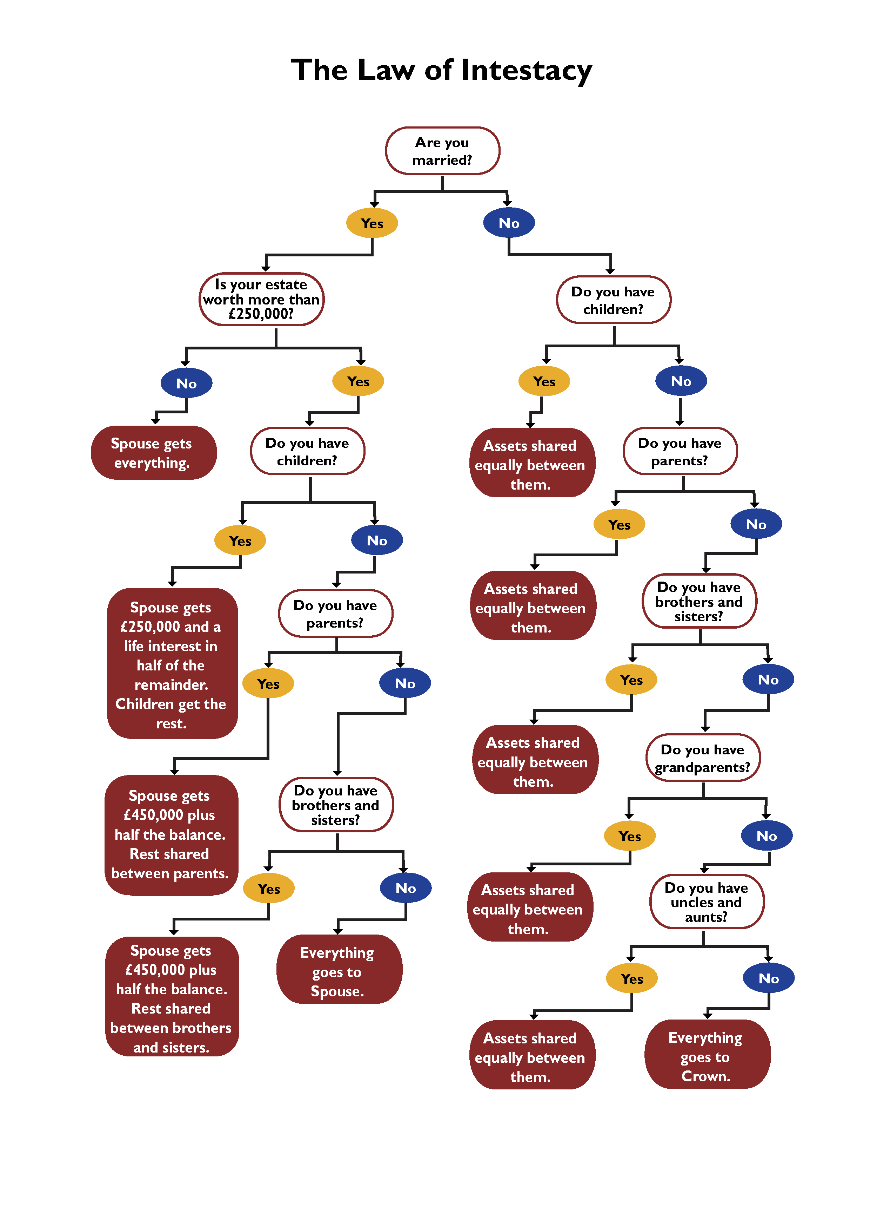](https://www.google.co.uk/url?sa=i&rct=j&q=&esrc=s&source=images&cd=&ved=0ahUKEwik9f_837vOAhUEORoKHQLLA68QjRwIBw&url=http://www.mindatrest.co.uk/blog/law-of-intestacy&bvm=bv.129422649,d.ZGg&psig=AFQjCNFOMR3cM_my0TzbpvSsw-eZx9tC_g&ust=1471086911306377)